***Proposed title:***

**Women’s Participation and Wellbeing in Weekly Food Markets: Gendered Insights from Dar es Salaam’s Urban Peripheries, Tanzania**

**Authors:**

Ngassa, C., Kinunda, N., Kissoly, L., and Norman, F.

**Abstract**

Weekly Food Markets (WFMs) are an increasingly important feature of urban food systems in sub-Saharan Africa, particularly in the underserved peripheries of rapidly growing cities. In Dar es Salaam, Tanzania, WFMs serve as critical access points for affordable and diverse foods. Despite their importance, the gendered dynamics within these markets remain underexplored. This study investigates women’s participation and well-being in WFMs, focusing on how socio-cultural norms, institutional arrangements, and structural barriers shape their engagement and economic outcomes. Drawing on mixed-methods research, including a cross-sectional survey of 381 vendors and 506 buyers across 31 WFMs, as well as focus group discussions and key informant interviews, the study applies the Social Relations Approach (SRA) to gender analysis. This framework allows for a nuanced examination of gendered access to resources, decision-making autonomy, and power dynamics within WFM environments. By focusing on WFMs—an emerging, municipally governed yet informally structured food retail model—this study aims to contribute new insights into the intersection of gender, market governance, and urban food provisioning. The findings will be particularly important for policy frameworks that recognize and support the unique role of women in WFMs and that promote inclusive urban food systems. Enhancing women's income stability, mobility, and autonomy within these spaces is key to realizing more equitable urban development and food security outcomes.

**Introduction**

Food markets play a pivotal role in ensuring urban households have access to affordable, diverse, fresh, and physically available nutritious foods. In sub-Saharan Africa (SSA), particularly in low-income urban settings, many residents rely more heavily on local markets and small retail shops than on supermarkets to meet their food needs (FAO, 2020; Davies et al., 2022). However, in urban peripheries, the availability of permanent food markets and informal retail outlets remains limited. This gap has contributed to the rise and evolution of Weekly Food Markets (WFMs) as an alternative mode of food provisioning. These periodic markets, held on a weekly or bi-weekly basis, typically consist of small-scale vendors selling directly to consumers in authorized public spaces. The vendors operate on a regular schedule—often once a week—and are permitted by local authorities, usually in exchange for a nominal fee (Hiebert et al., 2017). Despite their growing significance in the urban food system, WFMs remain largely understudied. While research on WFMs is gradually expanding, much of the focus has been on the range of products available, with limited attention to vendor characteristics—particularly from a gender perspective.

Existing literature on urban food vending underscores the prominent role of women in food markets. Female traders are known to dominate food vending activities across SSA cities (Davies et al., 2022; Giroux et al., 2021). However, these women often encounter systemic barriers such as restricted access to capital, limited control over market spaces, and inadequate infrastructure. In addition, socio-cultural constraints, including entrenched gender norms and community attitudes, further shape women’s participation and impact their economic opportunities and well-being outcomes (Kapinga et al., 2020; Davies et al., 2022).

While recent studies have begun to examine how social norms and gender roles mediate women’s productive and reproductive roles in food markets (de Kanter et al., 2024), little is known about how these dynamics play out in emerging typologies such as WFMs—especially in the urban peripheries. Most existing research on women’s engagement in food vending focuses on either permanent formal markets or the broader informal food economy (Cook et al., 2024; Peimani and Kamalipour, 2022). Yet WFMs occupy a unique position: although informal in nature, they are officially recognized and governed by municipal by-laws. Further, the spatial and temporal structure of WFMs, where vendors only trade once a week in a given location, requires vendors to maintain high levels of mobility across municipalities to sustain their livelihoods. This raises critical questions about whether women—due to mobility constraints, caregiving responsibilities, or structural inequalities—face particular disadvantages in these systems. Understanding these gendered dynamics is essential to informing policies that enhance women's participation, economic empowerment, and well-being in urban food systems.

This study therefore aims to: (i) explore the forms of women’s participation in WFMs and examine the socio-cultural and institutional factors that shape their engagement; (ii) assess the economic and well-being outcomes of women’s participation in WFMs, with a focus on income, economic security, and personal autonomy; (iii) and identify policy-relevant pathways for enhancing women’s participation in WFMs, emphasizing income stability, economic security, and autonomy. In doing so, the paper contributes to the growing body of research on gender and urban food markets by focusing on WFMs—an emerging yet underexplored market structure in urban peripheries. Unlike previous studies that emphasize women’s engagement in either permanent formal markets or the wider informal sector, this paper centres on WFMs as a distinctive, municipally regulated yet flexible market model. Through an examination of women’s participation, the socio-cultural and institutional factors shaping their engagement, and the resulting economic and well-being outcomes, the paper offers new insights into how market design and governance intersect with gender. Finally, the findings aim to inform more inclusive policy frameworks that support women's income security, autonomy, and broader empowerment within evolving food retail environments.

**Materials and Methods**

*Conceptual Framework*

We adopt the Social Relations Approach (SRA) to gender analysis, developed by Kabeer (1994) in collaboration with policymakers, scholars, and activists from a socialist feminist tradition. The SRA offers a comprehensive framework for exploring gendered inequalities in access to resources, division of responsibilities, and the distribution of power. This framework is particularly important as it is suited to contexts that aim to generate critical insights that can inform gender-transformative policies and promote women’s empowerment. It is built on five interlinked concepts: development as increased human well-being, social relations, institutional analysis, institutional gender policies, and the identification of immediate, underlying, and structural causes of inequality (Kabeer, 1994; March et al., 1999).

For the purpose of this paper, four of these concepts—development as well-being, social relations, institutional analysis, and institutional gender policies—are applied to investigate women’s participation in WFMs in Dar es Salaam and how such participation relates to both economic and human well-being outcomes. The SRA's emphasis on the institutional and relational dimensions of gender makes it particularly useful for understanding the complex dynamics of informal market environments.

*Study area and data*

We use the case of Dar es Salaam, Tanzania's commercial capital and one of Africa's most rapidly urbanizing metropolises. The city spans 1,393 km² across five municipalities - Kinondoni, Ubungo, Kigamboni, Ilala, and Temeke - housing approximately 5.3 million residents (NBS, 2022). Dar es Salaam presents an ideal case study due to two interrelated factors: its explosive peri-urban growth characterized by informal settlements and inadequate infrastructure (Lupala, 2021), where 37% of the city's population now resides according to 2022 census data; and its representative nature as a prototype for urbanization patterns seen across fast-growing sub-Saharan African cities. These characteristics make the city particularly relevant for investigating informal food markets and their gendered dimensions.

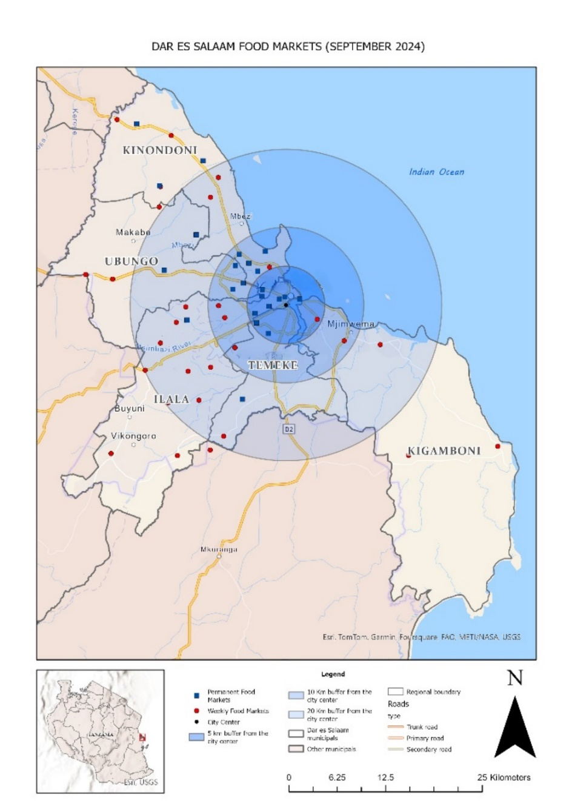

Figure 1: Study area (Weekly food markets in five wards of Dar es Salaam).

As Dar es Salaam undergoes rapid urban expansion, accompanied by rising demand for accessible food retail infrastructure, city authorities have responded by permitting food traders to operate on a weekly basis in designated open spaces located near residential areas in peripheral wards. This policy shift has led to the emergence of approximately 31 Weekly Food Markets (WFMs) across the city's five municipalities. These markets operate on specific days of the week, varying by municipality, and serve as critical nodes for food access and informal trade in the city’s urban peripheries.

The study adopted a combination of probability and non-probability sampling techniques. All 31 Weekly Food Markets (WFMs) identified across Dar es Salaam’s five municipalities were purposively selected to ensure comprehensive coverage. Given the informal nature of WFMs and the absence of a known sampling frame for vendors and buyers, sample size estimation was guided by multiple methodological approaches. These included Memon et al. (2020), who recommend minimum thresholds of 200 respondents for descriptive analysis and 250 for statistical inference, Green’s (1991) formula of 50 + 8k (with k representing the number of independent variables), and Cochran’s (1977) formula for infinite populations. Practical constraints such as time and budget were also considered. Ultimately, a total of 381 vendors and 506 buyers were sampled, achieving a balance between methodological rigor and feasibility.

Data collection integrated both quantitative and qualitative approaches. The quantitative component consisted of a cross-sectional survey of 381 vendors across the 31 WFMs, comprising 55% women and 45% men. The survey gathered data on vendor demographics, types of food sold, access to resources, and levels of decision-making autonomy, allowing for gender-based analysis of patterns and disparities. Qualitative data were collected through five Focus Group Discussions (FGDs)—one per municipality—with 5 to 7 purposively selected participants in each, identified with the help of WFM leaders. A maximum variation sampling approach was applied to capture a wide range of experiences and perspectives (Palinkas et al., 2015; Manyungwa et al., 2019). Each FGD included both male and female participants and followed a semi-structured guide (see Annex 1), covering themes such as participation, access to market spaces, decision-making, and well-being outcomes.

Additionally, Key Informant Interviews (KIIs) were conducted with a range of actors, including WFM leaders, municipal officers in urban planning, trade, and business departments, as well as relevant national-level officials. These interviews provided institutional insights into the governance and planning of WFMs, and the extent of gender inclusion in market processes.

Taken together, the mixed-methods approach offers a comprehensive understanding of the gendered dimensions of food vending in Dar es Salaam’s urban peripheries. It sheds light on the institutional and relational dynamics that shape women’s participation, access to opportunities, and well-being outcomes in the evolving landscape of WFMs.

*Analytical Techniques*

The study employed a mixed-methods approach, integrating both exploratory and cross-sectional research designs. The exploratory component involves Focus Group Discussions (FGDs) aimed at deepening understanding of gendered factors that shape the supply of nutritious food in WFMs. These discussions help identify key variables, contextual dynamics, and social relationships that influence women’s engagement in the market system. The cross-sectional design complements this by using a structured market survey to quantitatively assess the characteristics of vendors, the types of food sold disaggregated by gender, and decision-making roles within the marketplace.

Qualitative data from Focus Group Discussions (FGDs) and Key Informant Interviews (KIIs) were transcribed and analyzed using NVivo software. Thematic analysis was applied to identify key gender dynamics, decision-making processes, and access to market resources. NVivo enabled systematic coding, helping to uncover patterns and insights from the data. This approach ensured a thorough, transparent analysis and contributed to the triangulation of qualitative and quantitative findings.

By combining these approaches, the study generates context-specific, empirically grounded insights that are both explanatory and policy-relevant. This design allows for a nuanced analysis of how gender shapes participation in WFMs and influences outcomes related to economic empowerment and well-being.

**Results (***This section is still being drafted***)**

*Women participation in WFMs*

Number of food vendors, by gender across municipalities

Table 1 Percentage of vendors by gender across municipalities

Figure 1 Percentage of vendors by gender across municipalities

Food items sold (The 12 FAO, 2018 food groups) by gender

Figure 2. Food groups (12 Food groups by FAO, 2028) sold regularly by gender of the vendor

Figure 3. The 6 Food groups by the TFBDG, (MoH, 2028) sold regularly by gender of the vendor

Number of WFMs vendors that participate (by gender)

Figure 4. Number of WFMs that the Vendor participates

*Decision Making regarding participation in WFMs*

Decisions (what to sell, which WFMs to participate, business size)

Figure 5. Decision making by gender of the vendors (number)

Or

Figure 5. Decision making by gender of the vendors (percentage)

*Women’s Participation in WFMs based on the SRA framework*

*Economic and overall well-being Outcomes of Women’s Participation in WFMs*

*Challenges Facing Women Traders in WFMs*

**Discussion**

**Conclusions**

**References**

1. Cook, B., Trevenen-Jones, A., & Sivasubramanian, B. (2024). Nutritional, economic, social, and governance implications of traditional food markets for vulnerable populations in sub-Saharan Africa: A systematic narrative review.Front. Sustain. Food Syst. 8:1382383. doi: 10.3389/fsufs.2024.1382383
2. Davies, J., Blekking, J., Hannah, C., Zimmer, A., Joshi, N., Anderson, P., Chilenga, A., & Evans, T. (2022). Governance of traditional markets and rural-urban food systems in sub-Saharan Africa*.* Habitat International 127 (2022) 102620. <https://doi.org/10.1016/j.habitatint.2022.102620>
3. de Kanter, E., Trevenen-Jones, A., & Billiard, C. M. J. (2024). Nutrition security and traditional food markets in Africa: Gender insights*.* Frontiers in Sustainability, 4, Article 1321499. <https://doi.org/10.3389/frsus.2024.1321499>
4. Giroux, S., Blekking, J., Waldman, K., Resnick, D., & Fobi, D. *(*2021*).* Informal vendors and food systems planning in an emerging African city*.* Food Policy 103 (2021) 101997.
5. <https://doi.org/10.1016/j.foodpol.2020.101997>
6. Kabeer, N. (1994). *Reversed Realities: Gender Hierarchies in Development Thought*. Verso, London.
7. Kapinga, A. F., & Montero, C. S. (*Year*). Exploring the socio-cultural challenges of food processing women entrepreneurs in Iringa, Tanzania, and strategies used to tackle them. Journal of Global Entrepreneurship Research (2017) 7:17. DOI 10.1186/s40497-017-0076-0
8. Ludgate, N. (2926). *Integrating Gender and Nutrition within Agricultural Extension Services*: Harvard Analytical Framework. Feed the future. The U.S. Government’s Global Hunger & Food Security Initiative-
9. Manyungwa, C.L., Hara, M.M. & Chimatiro, S.K. (2019). Women’s engagement in and outcomes from small-scale fisheries value chains in Malawi: effects of social relations. *Maritime Studies* 18, 275– 285 (2019). <https://doi.org/10.1007/s40152-019-00156-z>
10. March, C., Smyth, I., & Mukhopadhyay, M. (1999). *A Guide to Gender-Analysis Frameworks*. An Oxfam Publication. Iitho and Digital Impressions Ltd, Witney. ISBN 085598 4031
11. Palinkas, L.A., S. Horwitz, C. Green, J.P. Wisdom, N. Duan, and K. Hoagwood. 2015. Purposeful sampling for qualitative data collection and analysis in mixed method implementation research. *Administration and Policy in Mental Health 42 (5): 533–544*. <https://doi.org/10.1007/s10488-013-0528-y>.
12. Peimani, N., & Kamalipour, H. (2022). Informal street vending: a systematic review. *Land*, *11*(6), 829.

**Annex 1: Broad and specific research questions to guide analysis**

|  |  |  |
| --- | --- | --- |
| **SN** | **Broad area** | **Specific questions** |
| 1 | Women’s Participation in WFMs | * What types of activities do women engage in within WFMs (e.g., productive, distributive, or regulatory roles)? * How do gendered social relations shape roles and responsibilities in WFMs, particularly across different income groups? * In what ways do norms, values, laws, traditions, and customs influence women’s participation in WFMs, including access to trading spaces and business information? * What policies govern WFMs, and how do institutional norms, laws, and decision-making structures shape gendered participation? |
| 2 | Challenges Facing Women Traders in WFMs | * What challenges do women traders encounter in WFMs concerning the trading environment, gender-based discrimination, socio-cultural barriers, and entrepreneurship? |
| 3 | Outcomes of Women’s Participation in WFMs | * How does participation in WFMs influence women’s income, economic security, and personal autonomy? * How do socio-cultural factors, including norms and traditions, mediate the economic and well-being outcomes of women vendors? |

**Annex 2: FGDs Questions based on Social Relations Approach**

|  |  |
| --- | --- |
| **The SRA concept** | **FGDs Questions** |
| 1. *Development as Increasing Human Well-Being* | 1. How does WFMs participation influence females’ income? 2. How does WFMs participation influence females’ economic security? 3. How does WFMs participation influence females’ personal autonomy? 4. How does WFMs participation influence females’ overall well-being? |
| 1. *Social relations* | 1. What activities are conducted in WFMs, What activities do women mostly participate? 2. About participation in WFMs—are there any gendered barriers? 3. Does gender social relations determines the roles and responsibilities of WFMs Vendors across different groups?. (Poor? women?)  * *Productive activities:* Selling of the specific food items (12-food groups). Who dominates selling of the given food item? And why? (ask for all 12 food-groups) * *Reproductive activities.* How does reproductive activities influence women participation in WFMs * *Distributive activities:* Allocation of resources (e.g. space, stalls). Who normally does it, why? * *Regulative activities*: markets rules (e.g. working hours, hygiene, and entry to WFMs). Who normally does it, why?  1. Are there marginalized groups among vendors? (e.g. Poor people, poor women, youth….) 2. How these are marginalized groups treaded when it comes to allocation of WFMs resources? |
| 1. *Institutional analysis* | 1. *Rules*: Identify norms, values, laws, traditions and customs that influence the way of doing things in the WFMs. (NK identify them)    * How do they affect females’ participation in WFMs?, and space/stall allocation? What about the disadvantaged groups?    * How do they affect females’ income, economic security, personal autonomy, and overall well-being? What about the disadvantaged groups? 2. *Activities*: Identify the productive, distributive, or regulative activities in WFMs. How does what?, how gets what? 3. *Resources:* (what is used, what is produced?): How has Access?    * material ones (land-i.e.space), or    * intangible ones (market information). 4. *People:* (who is in, who is out, who does what?)    * who they allow in and whom they exclude to participate in WFMs;    * who is assigned various resources, tasks, and responsibilities;    * who is positioned where in the hierarchy    * How does it influence females’ income, economic security, personal autonomy, and overall well-being outcomes? 5. *Power:* who decides, and whose interests are served?    * How does this power relation shape Participation of different groups in WFMs (women?, poor?)    * How does this power relation shape women income, security, autonomy and well-being outcomes of different groups in WFMs (women?, poor?) |
| 1. *Institutional gender policies* | In this municipality, what is nature of current institutional gender policies?   * *Gender-blind policies*: (recognize no distinction between the sexes (favours existing gender relations and therefore tend to exclude women). * *Gender-aware policies*: (recognize that women and men are development actors, and have unequal relationship:   + *Gender neutral policies* (interventions intended to leave existing distribution of resources and responsibilities unchanged)   + *Gender-specific policies* (interventions intended to meet targeted needs of women/ men, within the existing distribution of resources and responsibilities)   + *Gender-redistributive policies* (interventions intended to transform existing distribution of resources and responsibilities to create balanced gender relationship) * How does this policies shape Participation of different groups in WFMs (women?, poor?) * How does this policies shape women income, economic security, personal autonomy and overall well-being outcomes of different groups in WFMs (women?, poor?) |
| *Other questions* | * What challenges do women traders encounter in WFMs concerning * the trading environment, * gender-based discrimination, * socio-cultural barriers, and * entrepreneurship? * administration |